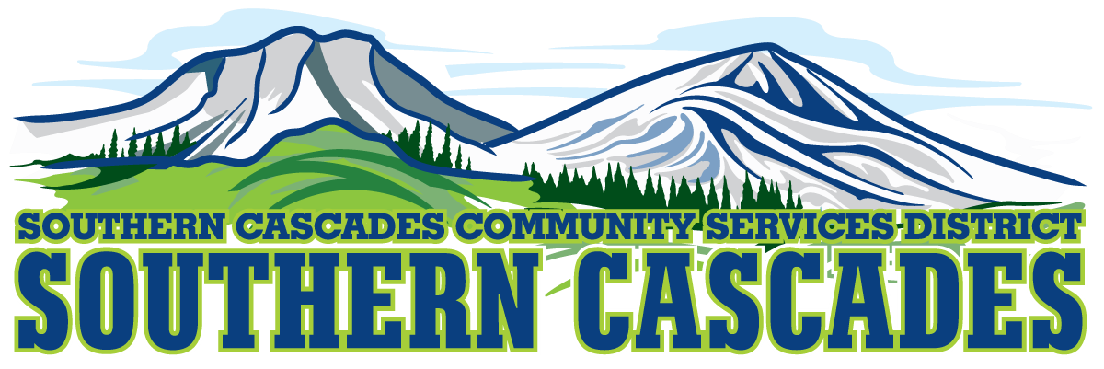
Southern Cascades Operations Base and Training Center
Conference Room
205 Ash Valley Road, Adin, CA 96006
December 15, 2025 - 5: 00 PM
Regular Board Meeting Agenda
1.0 Call to Order
2.0 Pledge of Allegiance
3.0 Roll Call and Establishment of a Quorum of the Board of Directors

4.0 Deletions /Additions and Approval of Agenda
5.0 Public Comment: This is the time set aside for citizens to address the Board on matters on the consent agenda and matters not otherwise on the agenda. Comments should be limited to matters within the jurisdiction of the Board. If your comment concerns an item shown on the agenda. Please address the Board after that item is open for public comment. By law, the Board cannot take action on matters that are not on the agenda. The chair reserves the right to limit the duration of each speaker to three minutes. The speaker may not cede their time. Agenda items with times listed, will be considered at that time. All other items will be considered as listed on the agenda or as deemed necessary by the Chairperson.
6.0 CLOSED SESSION-
6.1 Per Government Code §54957, Public Employee Performance Evaluation- District General Manager
6.2 Per Government Code §551.071, Real Property Negotiations
7.0 Reconvene to Open Session
8.0 Reports
8.1 CFO Report
8.2 EMS/Education Division Manager Report
8.3 General Manager Report
9.0 Action Items
9.1 Approve board minutes from 11.17. 2025 Regular Board Meeting
10.0 Adjournment
Parties with a disability as provided by the American Disabilities Act who require special accommodations or aides in order to participate in the public meeting should make the request by calling 530 299 3110 at least 24 hours prior to the meeting. Posted at Southern Cascades Operations Base and Training Center Foyer and the SCCSD Web Site December 12, 2025.

