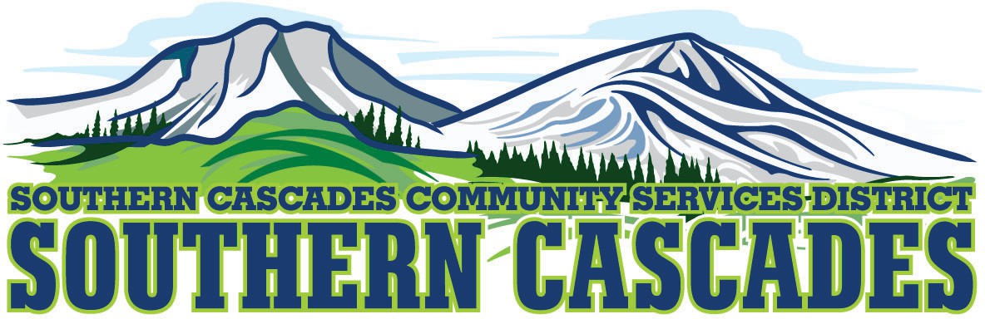
Southern Cascades Board Room
205 Ash Valley Road, Adin, CA 96006
Finance Committee Meeting
Minutes for December 15, 2025, 4:00 PM

- November financials were reviewed

- Five Star Bank statements were reviewed and reconciliations

- Discussed anticipated revenue increase for the month of December with the current influx of trips

- Adjourn at 5:00 PM

Attest: Karli Frye- District General Manager_______________________ Date____________

