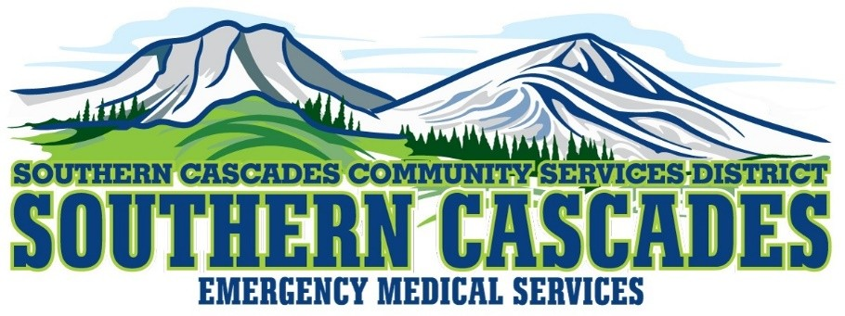
205 Ash Valley Rd, PO Box 239, Adin CA 96006

Student Application
Name:_______________________________________________________________________
Home Address: ________________________________________________________________
_____________________________________________________________________________
Mailing Address: _______________________________________________________________
_____________________________________________________________________________
Email Address: ________________________________________________________________
Home Phone Number: _____________________Cell Phone Number: ____________________
Date of Birth:__________________________________________________________________
Class (circle class you are applying for): EMR EMT EMT Refresher
Current AHA BLS Certification (circle yes or no): YES NO
Currently employed or volunteer as EMT? (circle yes or no): YES NO
Current EMT certification? (circle yes or no): YES NO
Current EMR certification? (circle yes or no): YES NO
Why do you want to take the EMT class in Adin?

__________________________________________________________________________________________
__________________________________________________________________________________________

STUDENT NAME:_______________________________________________________________ SIGNATURE:_________________________________________DATE:_____________________
Completed applications to be emailed to | :
gsolorio@southerncascades.org

